1. **Game Interface Introduction**
   1. Games

Just a box to test the linking between front end and back end and will be dropped later.

* 1. Score

It shows the total score of the current player and opponents.

* 1. Words Played

A box shown on the top right of the game page to illustrate the formed words.

* 1. Tiles Left

A box shown on the bottom right of the game page to illustrate the tiles left in the tile bag.

* 1. Board

15×15 squares for players to drag the letter on the board to make works.

|  |  |  |
| --- | --- | --- |
| Special Square | Figure | Description |
| Star | ST | The first player must start game by dragging the first tile on the center star square on the board. |
| Double Letter | DL | When user drop letters on the squares with this background and form a word successfully, the score of the letter will be doubled. |
| Double Word | DW | When user drop letters on the squares with this background and form a word successfully, the score of the whole word will be doubled. |
| Triple Letter | TL | When user drop letters on the squares with this background and form a word successfully, the score of the letter will be tripled. |
| Triple Word | TW | When user drop letters on the squares with this background and form a word successfully, the score of the whole word will be tripled. |

* 1. Buttons

|  |  |
| --- | --- |
| Name | Function Description |
| Play | After players drag the letter on the board, click play button will check whether it form a word and calculate the score. |
| Pass | If the player can not make a word and want to skip the current round, click the pass button. |
| Clear | If the player drag some tiles on the board and want to remove them all, just click the clear button to recover the move. |
| Swap | Users can click this button to swap the letters shown on the page with the reminder letters in the tile bags. |

* 1. Tiles

It contains six letter squares randomly chosen from the tile bag. Different letters have different scores and score is displayed in the bottom right corner of the square. Letters that often appears in words like e,a, o have lower scores than those rarely show up in words.

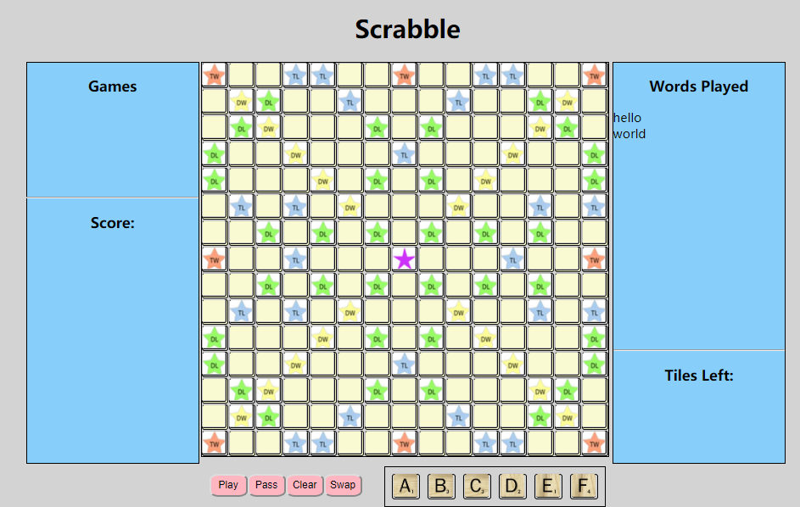

1. **Rules**

**2.1Game Play Rules**

①The players of the game can be 3~6.

②Players can choose normal mode and AI mode that one player is computer.

③The first player combines and drags two or more of his or her letters to form a word on the board to read either across or down with one letter on the center square. Diagonal words are not allowed.

④Click play button to count and announce your score for that turn. Always keep six letters on your rack, as long as there are enough tiles left in the tile bags.

⑤New words maybe formed by:

Adding one or more letters to a word or letters already on the board.

Placing a word at right angles to a word already on the board. The new word must use one of the letters already on the board or must add a letter to it.

Placing a complete word parallel to a word already played so that adjacent letters also form complete words.

⑥No tile maybe shifted or replaced after it has been played and scored.

⑦Blanks: The blank tiles may be used as any letters. When playing a blank, you must state which letter it represents. And it remains that letter for the rest of the game.

⑧The game ends when all letters have been drawn and one player uses his or her last letter; or when all possible plays have been made.

**2.2 Scoring Rules**

①The ‘Score’ box on the game page shows each player's score, entering it after each turn. The score value of each letter is indicated by a number at the bottom of the tile. The score value of a blank is zero.

②The score for each turn is the sum of the letter values in each word(s) formed or modified on that turn. If the letter is placed on the bonus squares, the score of letter or the whole word will be doubled or tripled.

③Letter and word premiums count only on the turn in which they are played. On later turns, letters already played on premium squares count at face value.

④When two or more words are formed in the same play, each is scored. The common letter is counted (with full premium value, if any) for each word.

⑤The player with the highest final score wins the game.

1. **Home Page Introduction**